**Title of presentation**

**Author One1, Author Two2, Author Three3**

1. Institute of…
2. University of Technology…
3. Center for…

A laser diode (LD, also injection laser diode or ILD or semiconductor laser or diode laser) is a semiconductor device similar to a light-emitting diode in which a diode pumped directly with electrical current can create lasing conditions at the diode's junction.[1]: 3 Driven by voltage, the doped p–n-transition allows for recombination of an electron with a hole. Due to the drop of the electron from a higher energy level to a lower one, radiation, in the form of an emitted photon is generated. This is spontaneous emission. Stimulated emission can be produced when the process is continued and further generates light with the same phase, coherence and wavelength. The choice of the semiconductor material determines the wavelength of the emitted beam, which in today's laser diodes range from infrared to the ultraviolet (UV) spectrum. Laser diodes are the most common type of lasers produced, with a wide range of uses that include fiber-optic communications, barcode readers, laser pointers, CD/DVD/Blu-ray disc reading/recording, laser printing, laser scanning and light beam illumination. With the use of a phosphor like that found on white LEDs, laser diodes can be used for general illumination.

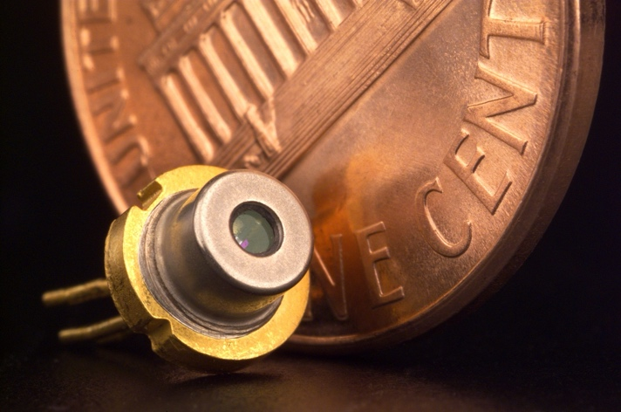

Laser with damaged pins